DSL = domain specific language

Rails DSL is plain ruby code

Java is explicit and is a bad DSL

Implicit what?

* Self
* Variable declarations
* Parentheses

Can we see the Rails DSL as Ruby’s basic Building Blocks?

1. Assigning values to variables
2. Sending messages to Objects

JavaScript: Explicit

Ruby: often Implicit

Parentheses are different in Ruby compared to JS

* In JS parens means function invocation and without parens, it is a value
* In Ruby, parens are optional

Ruby zero arg method calls are indistinguishable from values

* User.first vs User.first

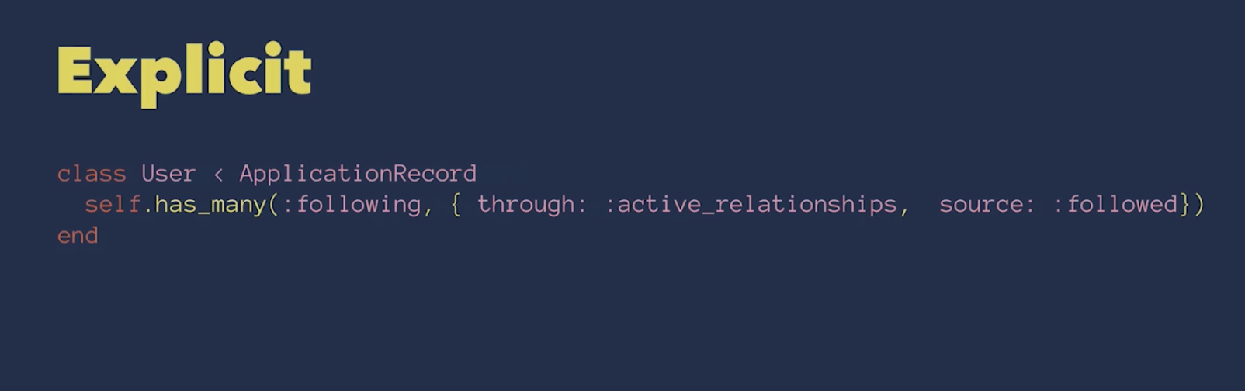

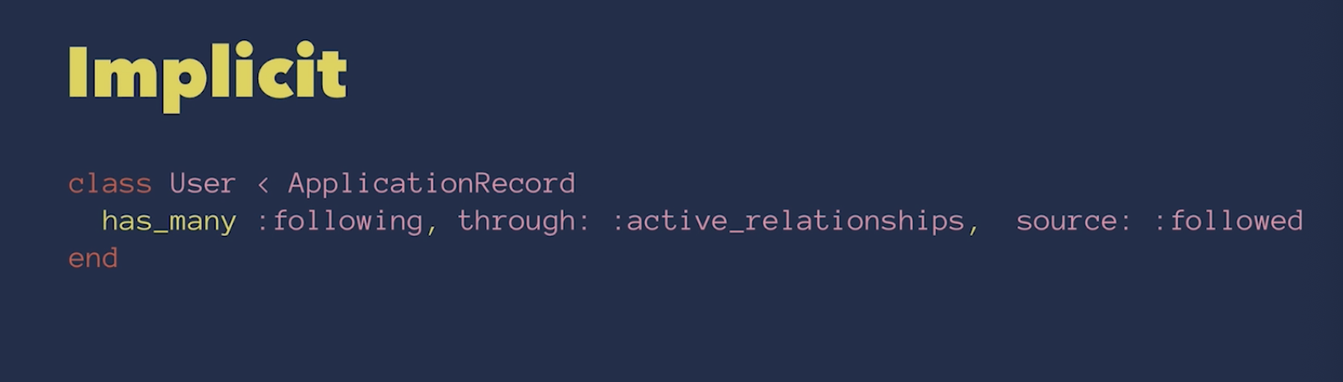

Custom Operators => Implicit Parens

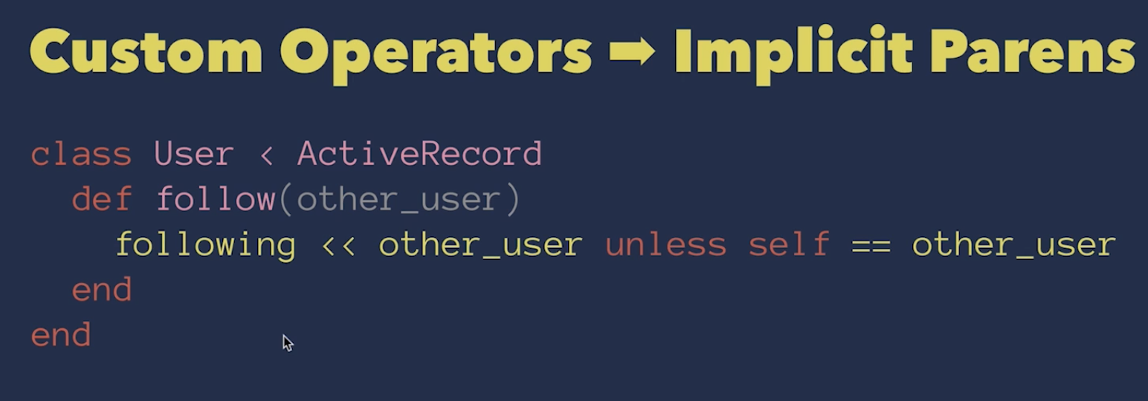

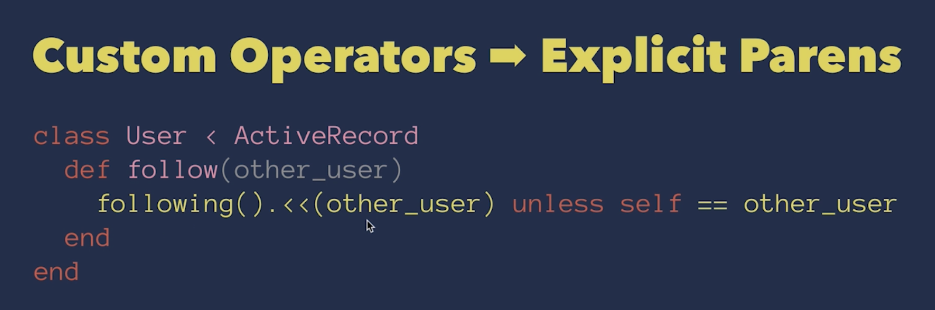

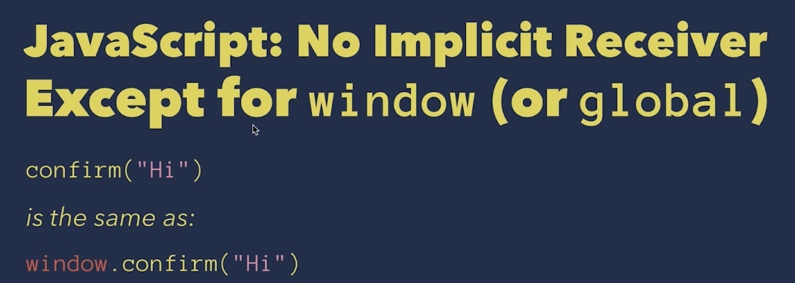

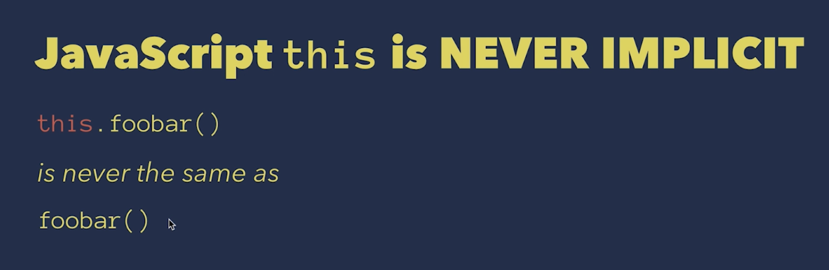

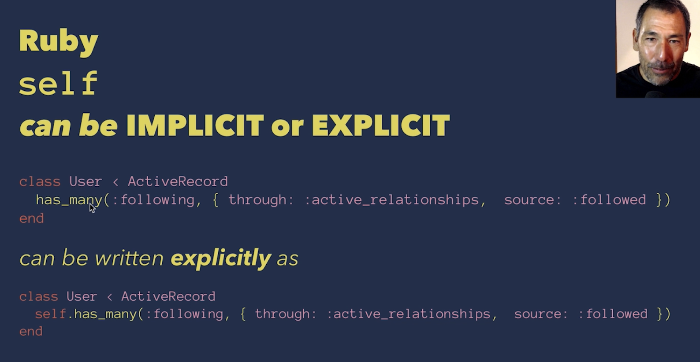

Calling self outside of classes will show that it refers to main

`$ function_name` will show you the source location of a function of object

`? function_name` will show you the docs for function_name

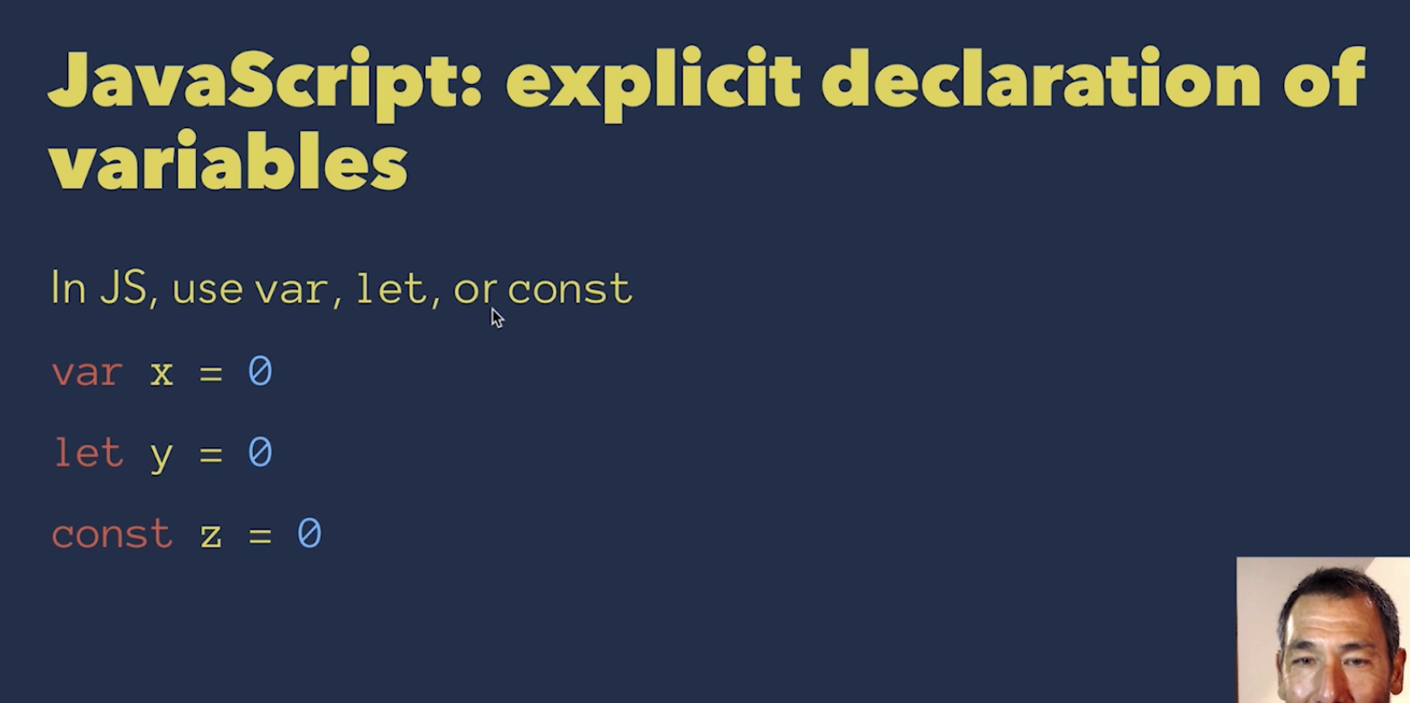

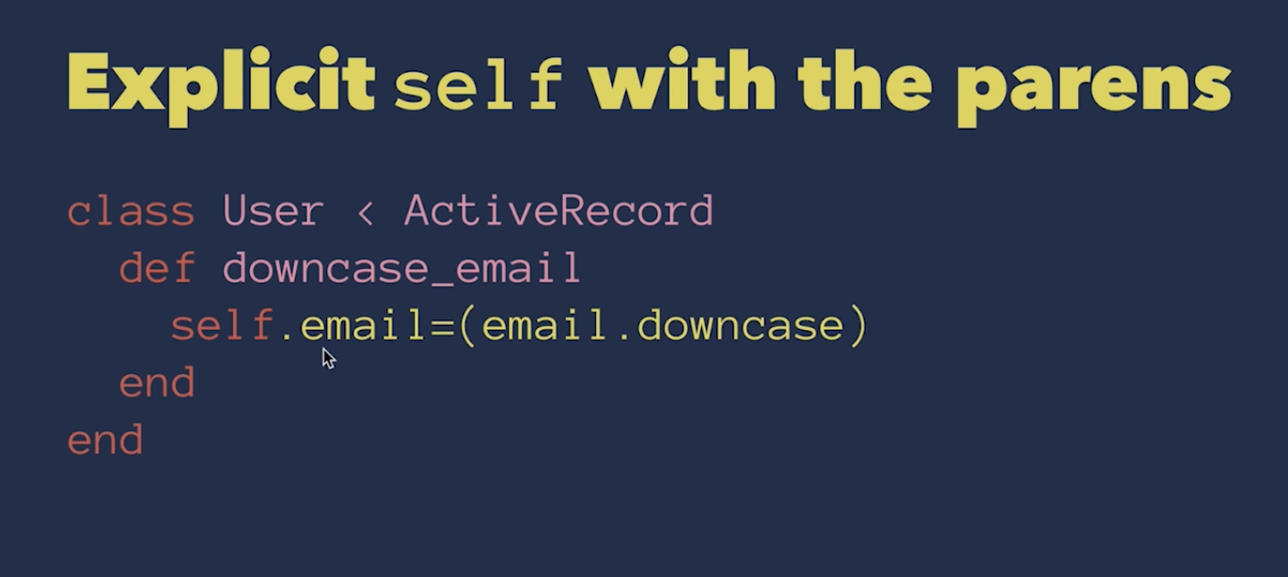

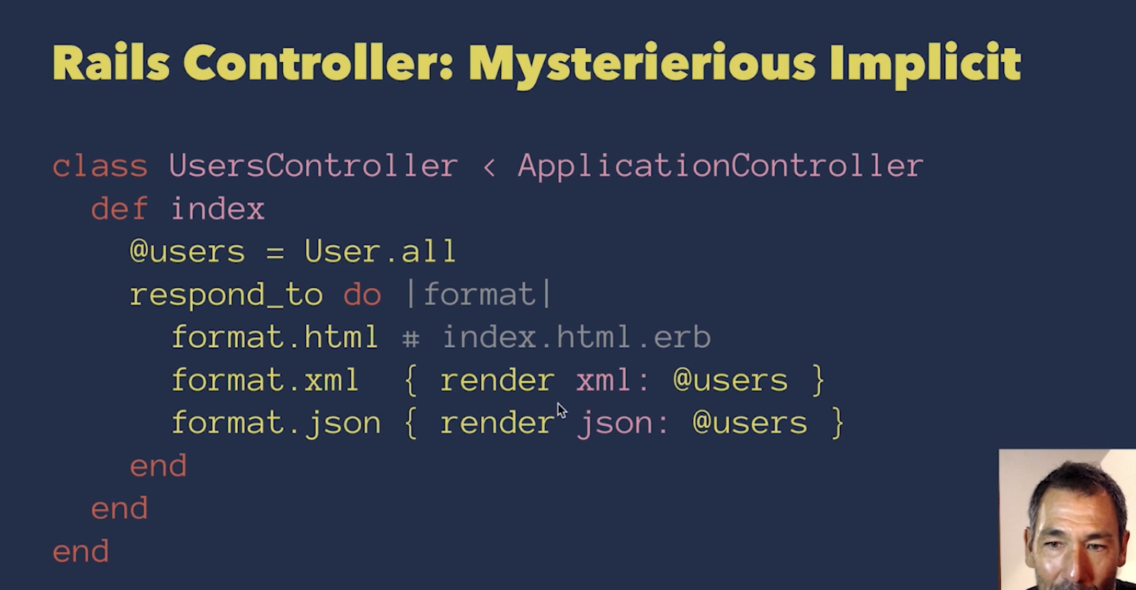

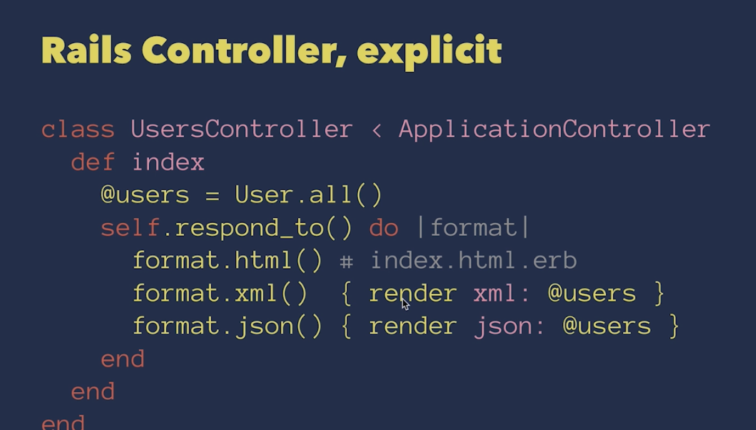

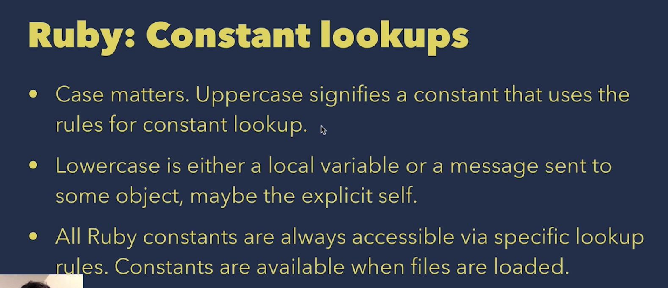

Useful binding.pry commands:

* show-docs
* Show-source
* Ls: shows methods on object

Method_missing

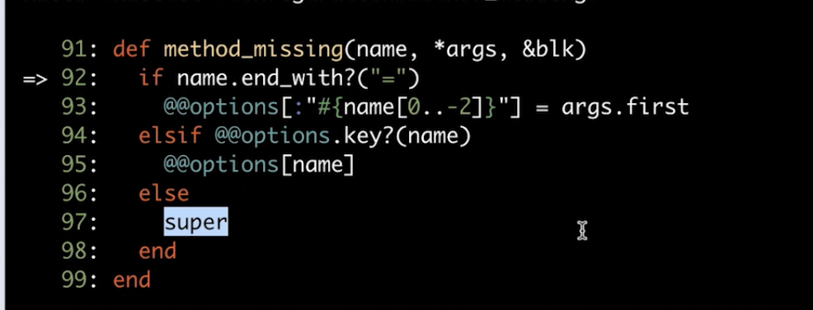

* Will set to options if it’s equal to else it will go up the hierarchy tree